Test Application: https://demo.testfire.net/
Date: July 21, 2025
Test Type: Security Vulnerability Testing

Test Case 1: SQL Injection Authentication Bypass
Test Case ID:01
Test Case Title: Verify SQL Injection vulnerability in login authentication
Vulnerability Type: SQL Injection
Test Priority: High
Severity: Critical
Pre-conditions:
● Navigate to https://demo.testfire.net/
● Application login page is accessible
● No user is currently logged in
Test Steps:
1. Open the login page at https://demo.testfire.net/login.jsp
2. In the Username field, enter the SQL injection payload: ' OR '1'='1
3. In the Password field, enter any value (e.g., "anything")
4. Click on the "Login" button
5. Observe the application response
Expected Results:
● Login should fail with invalid credentials
● Error message should be displayed
● User should remain on login page
Actual Results:
● Application logs the user in as Admin
● Authentication bypass successful
● User gains unauthorized access to administrative functions
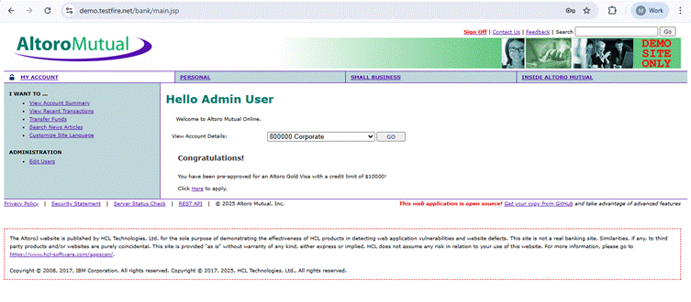

Test Case 2: Cross-Site Scripting (XSS) in Search Field
Test Case ID: 02
Test Case Title: Verify XSS vulnerability in search functionality
Vulnerability Type: Cross-Site Scripting (XSS)
Test Priority: High
Severity: High
Pre-conditions:
● Navigate to https://demo.testfire.net/
● Application homepage is loaded
● Search functionality is available
Test Steps:
1. Open the TestFire homepage at https://demo.testfire.net/
2. Locate the search field on the page
3. Enter the XSS payload: <script>alert('You are Hacked!');</script>
4. Submit the search query
5. Observe the application response
Expected Results:
● Search query should be sanitized
● No JavaScript execution should occur
● Search results or error message should be displayed safely
Actual Results:
● JavaScript alert box pops up displaying "Hacked!"
● XSS payload executes successfully
● User input is not properly sanitized
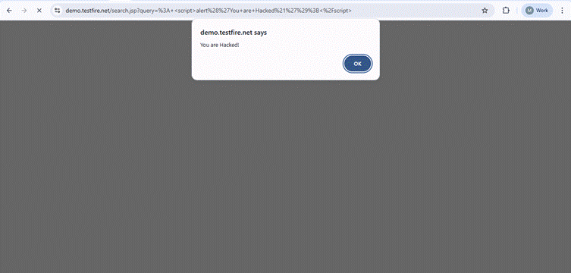

Test Case 3: Sensitive Data Exposure in Account Details
Test Case ID: 03
Test Case Title: Verify exposure of sensitive account information
Vulnerability Type: Sensitive Data Exposure
Test Priority: Critical
Severity: Critical
Pre-conditions:
● Navigate to https://demo.testfire.net/
● Valid user credentials are available (jsmith/demo1234)
● User account has associated bank accounts
Test Steps:
1. Open the TestFire homepage at https://demo.testfire.net/
2. Login using credentials: Username: "jsmith", Password: "demo1234"
3. Navigate to the Welcome page after successful login
4. Click on "View Account Details" for different accounts
5. Examine the account information displayed
6. Check if full account numbers are visible
7. Navigate to Transfer funds page
8. Observe account number display in dropdown menus
Expected Results:
● Account numbers should be masked (e.g., --****-1234)
● Only last 4 digits should be visible to user
● Sensitive financial data should be protected from exposure
Actual Results:
● Full account numbers are displayed in clear text
● Complete sensitive financial information is exposed
● No masking or protection of account details implemented

